AI-ASSISTED CODING
ASSIGNMENT-1.1
---------------------------------------
NAME: Adepu Goutham Sri Bhargav
HALL-TICKET: 2403A510C4
BATCH NO: 05

Task 1: Factorial without Functions
● Description:
Use GitHub Copilot to generate a Python program that calculates the factorial of a number without defining any functions (using loops directly in the main code).

Prompt:
Give a Python program that calculates the factorial of a number without defining any functions which takes user input.

CODE SCREENSHOT:
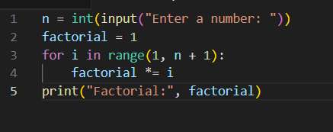
OUTPUT:


EXPLANATION:
A factorial code calculates the product of all positive integers up to a given number n. The factorial of n is written as n! and defined as:
n! = n × (n-1) × (n-2) × ... × 1
For example, 5! = 5 × 4 × 3 × 2 × 1 = 120.
A typical factorial function (in Python) looks like this:
- If n is 0 or 1, the function returns 1 (by definition).
- Otherwise, it multiplies n by the factorial of n-1 (recursion).
- This continues until n reaches 1.
--------------------------------------------------------------------------------------------------------------
Task 2: Improving Efficiency
● Description:
Examine the Copilot-generated code from Task 1 and demonstrate
how its efficiency can be improved (e.g., removing unnecessary variables, optimizing loops).
Prompt: give improved version code of task 1

CODE SCREENSHOT:
(original with functions)

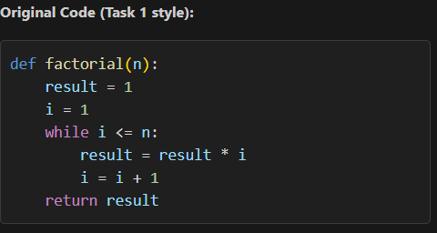

( Improved version without any extra variables, optimizing loops):
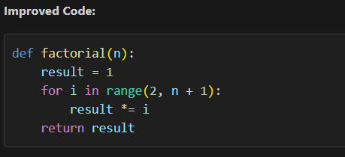
EXPLANATION:
- The improved code reduces unnecessary variable assignments and uses a for loop, which is generally faster and more readable than a while loop for this case.
- Starting from 2 skips a redundant multiplication.
- The code is shorter, easier to maintain, and may run slightly faster due to fewer operations and better loop optimization by Python.
----------------------------------------------------------------------------------------------------------
Task 3: Factorial with Functions
=>Description:
Use GitHub Copilot to generate a Python program that calculates the
factorial of a number using a user-defined function.
PROMPT:
Generate a Python program that calculates the factorial of a number using a user-defined function.
CODE:
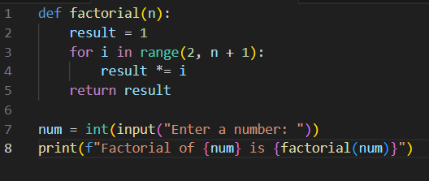
OUTPUT:
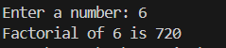
EXPLANATION:
- The factorial function computes the factorial using a loop.
- The user is prompted to enter a number, and the result is displayed.
------------------------------------------------------------------------------------------------------------
TASK 4: Comparative Analysis – With vs Without Functions
● Description:
Differentiate between the Copilot-generated factorial program with
functions and without functions in terms of logic, reusability, and
execution.
PROMPT:
Generate a python code to calculate factorial of a given number with and without functions.
CODES:
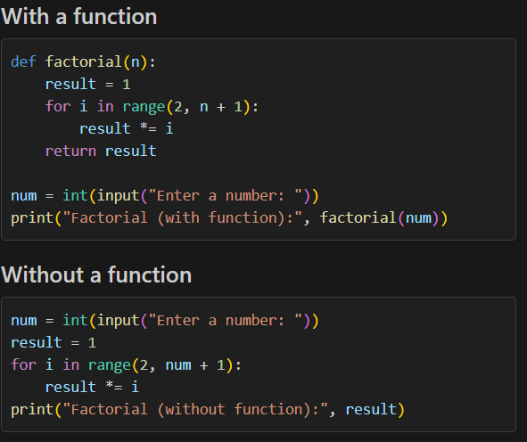
OUTPUT:
==>>.Both approaches will give the same result. The function version is reusable and cleaner, while the non-function version is direct and simple.
EXPLANATION:
Here’s a comparison of factorial calculation with and without a function in table form:
Approach | Code Snippet | Explanation
With Function | def factorial(n):<br> result = 1<br> for i in range(2, n + 1):<br> result *= i<br> return result<br>num = int(input("Enter a number: "))<br>print("Factorial (with function):", factorial(num)) | Defines a reusable function factorial(n) that calculates the factorial. User input is passed to the function and result is printed.
Without Function | num = int(input("Enter a number: "))<br>result = 1<br>for i in range(2, num + 1):<br> result *= i<br>print("Factorial (without function):", result) | Calculates factorial directly in the main program using a loop, then prints the result. No function is used.
This table shows the code and explanation for both methods side by side for easy comparison.
--------------------------------------------------------------------------------------------------------------
TASK 5: Iterative vs Recursive Factorial
● Description:
Prompt GitHub Copilot to generate both iterative and recursive
versions of the factorial function.
Prompt:
Generate both iterative and recursive versions of the factorial function.
CODE 1:
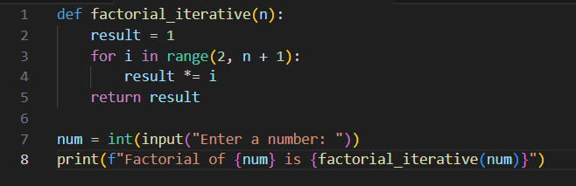
Output:

CODE 2:
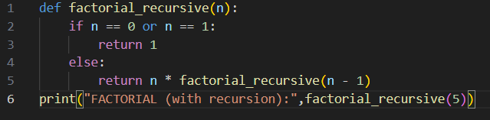
Output:
Explanation(comparing):
Aspect | Iterative | Recursive
Readability | Simple and clear | Elegant and closer to mathematical definition
Space Usage | O(1) (constant space) | O(n) (stack frames for each call)
Time Complexity | O(n) | O(n)
Overhead | Low (just loop) | Higher (function call overhead)
Risk of Errors | Minimal | Possible stack overflow for large n
Performance | Slightly faster due to no recursion | Slightly slower due to call overhead
Ease of Debugging | Easier (loop structure visible) | Slightly harder (nested calls)

